**SPRINT-2**

DATE

14

November

2022

TEAM

ID

PNT2022TMID36766

9

PROJECT

NAME

Industry-specific

intelligent

fire

management

system

**MONITORING**

**SENSOR**

**S**

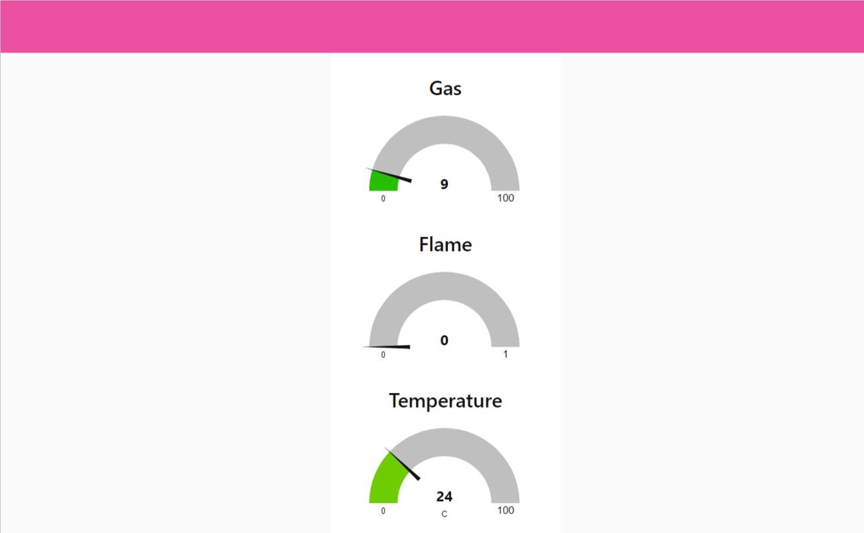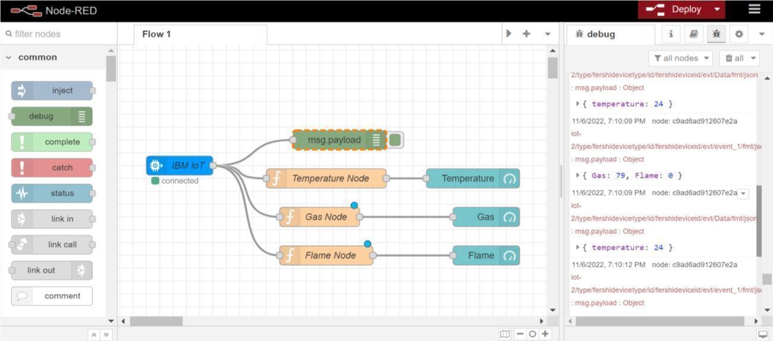

**SENSOR**

**VALUES**

